 

INSTITUTE FOR ADVANCED COMPUTING AND SOFTWARE DEVELOPMENT AKURDI, PUNE

Documentation On

**“**Online Pizza Ordering System**”**

E-DAC SEP 2020

*Submitted By:*

**Group No:58**

**Names :-Yogesh Sarode**

**(ROLL NO-2162)**

# Prashant Karhale Mr. Milind Arjun

**Centre Coordinator Project Guide**

**Table of Contents**

1. **Introduction 1**

Document Purpose 2

Problem Statement 2

Product Scope 2

Aim & Objectives 2

1. **Overall Description 3**

Product Perspective 3

Benefits of Online Pizza Ordering System 3

User and Characteristics 3

Operating Environment 3

Design and Implementation Constraints 3

1. **Requirements Specification 4**

External Interface Requirements 4

Non-Functional Requirements 12

1. **System Diagram 11**

Activity Diagram 11

Data Flow Diagram 13

Class Diagram 15

Use Case Diagram 16

ER Diagram 16

1. **Table Structure 17**

17

Notices 17

Complaints 17

Visitors 18

Bill 18

Workers 18

1. **Conclusion 19**

Future Scope 19

1. **References**

**List of Figures**

Figure 1 Activity Diagram 15

Figure 2 Data Flow Diagram 15

Figure 3 Data Flow Diagram 16

Figure 4 Use Case Diagram 17

Figure 5 ER Diagram:- 17

# Introduction:-

An online pizza ordering system is a web-based application that stimulates the customers to put pizza orders through internet by locating nearest Pizzavala. This application is based on the MySql, React js and Spring Hibernate platform . Online Pizza ordering system is a process in which one can order various pizzas and cuisines from Pizzavala through the use of internet, just by sitting at home or any place. And the order is delivered to the told location.

**1.1Document Purpose:-**

This document as a project report elaborates the Special features of the Online Pizza ordering system. This system is a bunch of beneﬁts from various point of views. As this online application enables the end users to register to the system online, select the different items of their choice from the menu list, and order pizza online.

* 1. **Problem Statement:-**

A pizza Delivery wants to develop a new web-based pizza ordering system that allows customers to enter orders in their web browsers. The System must be built for the Web Objects platform. The ordering system must be easy to use, as customers of all ages and expertise levels are supposed to use it. Customers may order pizzas with different types. Customer must be able to register for a customer account. A customer account stores address information but no payment details for security reasons.

* 1. **Product and Scope:-**

Online Pizza ordering system will be a web based application whose main language of programming will be Java. Its main aim is to simplify and improve the efficiency of the ordering process for both customer and pizza shop owners, minimize manual data entry and ensure data accuracy and security during order placement process. Customers will also be able to view product menus and their ingredients and be able to have a visual confirmation that the order was place correctly.

* 1. **Aim and Objective:-**

The main objective of this project is to develop an application which gives provision to the Pizzavala owners to ﬂourish their business by uploading menus at no cost and will invariably lead to higher customer retention and acquisition rates.

### **Features:-**

* Online menu
* Provision of restaurant owners to perform various operations like add, edit, update the menu items.
* Easy lookup of registered user on portal.
* Simple, fast and convenient ordering of food.
* Availability of the menu online 24x7.
* An online menu is ready to be viewed by people worldwide.
* Accuracy of changing the delivery status when pizza is out for delivery and delivered to the told location successfully.

# Overall Description:-

**2.1 Product Perspective:-**

Basically the main objective of this project is to do a functionalities of customer where they can add the products to the cart and finalised there order in the cart table. Where in the Admin section also admin can manages the menulist of the User Interface where admin can the add new products to the list and also update the product list and also can delete the products which admin don’t want to keep it in a menu list this system will helps to user and admin to do a functions in a easy manner.

* 1. **Benefits of Online Pizza Ordering System:-**

The rich variety of online websites makes customers do their wishes very quickly where this website helps to add products easily to cart for customers and admin Admin section also admin can manages the menu list of the User Interface where admin can the add new products to the list and also update the product list and also can delete the products which admin don’t want to keep it in a menu list this system will helps to user and admin to do a functions in a easy manner. This website will contains function such as add to cart,viewing menu,etc.

**2.3 User and Characteristics:-**

#### **Purpose**

#### **Login/Sign Up:**

When a customer visits the online pizza ordering system of any Pizzavala, he will be asked to log in or sign up for them for a better experience. The customer has to create a unique username and password. Then he /she need to enter details like Name, phone

number, address. After these steps account of that customer will be created.

#### **Customer proﬁle**

It contain information of customers as NAME

PHONE NUMBER EMAIL PASSWORD

#### **Types:-**

The system will provide customers a menu in which all the pizzas items will be shown with their prices. The pizzas on the menu are created by the professional chefs of the Pizzavala. The ingredients in this pizza can be changed according to the customer interests. The customer can select any pizza from the menu or build the custom pizza. Each pizza will be shown with their image and price. The ingredients used in the making of that pizza can also be seen. Each of these ingredients can be removed or other new ingredients can be added in the order. After each selection or de-selection, the grand total of the order will be updated.

#### **Add To Cart**

This feature is useful in a situation where you have to order more than one pizza or other non-pizza items. Suppose you have selected a Margherita pizza and now you want to select other pizza as well. Then you just have to add that pizza to the cart using the Add to cart option. Items added to the cart will be saved so that you can choose other pizzas as well. Finally, when you are ready to order you can check out from the cart to make payment.

#### **Payment**

There will online payment using Cash on delivery. order details are shown and conﬁrmed.

#### **Home Delivery or Pick up**

This feature asks the customer to if he/she intends to pick up his/her order from the Pizzavala or it is needed to be delivered to their address.

#### **Track your Order**

This is another interesting feature which helps customers to keep a track of his order. The customer is notiﬁed at every step of their order completion. After making payment the customer is shown the time by which his order will be delivered to his doorstep.

#### **Rating & Review**

when customer get their food he/she can give the rank or star according to what they like.They can give rank/star to hotel and delivery boy individually.

#### **Delivery Staﬀ**

Delivery boy Name delivery boy id (primary id) delivery boy salary contact no

address email id

order id(foreign key) Customer details:

customer_id-(foreign key) Delivery Details:

Customer Name Address Amount

Status (Picked-up, Out-for-Delivery, Delivered)

After order is prepared the available delivery staff is handed over the orders with their address. When the delivery staff leaves for delivery the status of the order is updated again to ‘Out for Delivery’ and the customer is notiﬁed.

When the delivery staff delivers the order successfully, he updates the order status to ’Delivered’. If he fails to deliver the order due to any reason, the status is updated to ‘Delivery Failure’.

#### **ADMIN**

#### **OPENING OR CLOSING STATUS OF Pizzavala**

Admin can choose opening and closing hours for the day.

Admin can decide whether Pizzavala is open or close for the orders.

##### **REGISTERED USERS DATA**-

Admin can fetch the customer data or can see the list of customers who sign up on the web site. Admin can not edit this data. This is the read-only data for admin.

But if user does any mischeif then he can suspend that particular user's account.

##### **CATEGORIES MANAGEMENT**-

Admin can see food categories available in Pizzavala.

Admin can edit / add new food categories.

##### **PAYMENT AKNOWLEDGEMENT-**

Admin can manually give payment acknolegement to the customer if payment gateway failed to provide status of transaction.

Manually payment acknolegement that is payment received / payment failed Admin can give order to prepare food only after payment received.

Admin provide invoice of order to customer.

##### **ORDERS MANAGEMENT-**

Admin can view ordered details provided by customer.

Admin can give information regarding status of food like order is accepted / food is preparing / food is cooked / food is on the way.

Admin then arrange delivery of food by alloting delivery guy.

#### **2.4 Operating Environment:-**

* Server Side:

**Processor:** Intel Dual Core

**HDD:** Minimum 80GB Disk Space

**RAM:** Minimum 2GB

**OS:** Windows 7, Linux

* Client Side (minimum requirement):

**Processor:** Intel Dual Core

**HDD:** Minimum 80GB Disk Space

**RAM:** Minimum 1GB

**OS:** Windows 7, Linux

# Requirements Specification:-

#### **3.1 Functional** **Requirements****:-**

##### **Customer**

This represents the set of customers, which are the clients who will be using this application. The customers are for whom the system is being designed. Its attribute set includes:

###### **Name:**

This is the name of the customer, searching or purchasing the products. When signing up to the website the name of customer is stored, this is done for the future referencing and maintaining the user’s data record (history). It is the composite attribute which contains two more attributes that is First_Name and Last_Name. That contains user’s ﬁrst name and last name.

###### **Customer_id:**

This is the identity number assigned by the admin to the users so as to identify them uniquely in future. This identity number is helpful in fetching data of individual user from a big set. This is mainly to manage the huge database system where the entire data is being stored. It is a permanent identity number given by the admin to the customer to maintain customer history.

###### **Customer_order_id:**

This is the identity number given to determine and manage the sequence of servicing. Since multiple customer will place orders, so as to schedule whom to give the delivery ﬁrst is determined by the help of this number, so as to maintain consistency in the system working procedure. It will be unique for each order.

###### **Address**

This ﬁeld is for the physical address of the customer where the restaurant authority is required to deliver the pizza. It may or may not the same as customer’s permanent address or resident. Its attribute includes:

###### **Address_id:**

An identity through which categorization of places may be done. As address unique for each customer registered. But still this identity helps the delivery person to identify the right place to deliver.

###### **Zip_code:**

It is the pin code or the postal code of a region, and which is utmost important in any address, since multiple places, streets, bungalows with same name exist. Also this will help the owner in surveying that which region of city has their more demand so as to expand their business in that region of city.

###### **Phone:-**

The users contact number is something that must be correct, because if at some point of time delivery person gets confuse with the address, it can be used for conﬁrmation. Also the restaurant authority can contact to their customers for any type of feedback or to know the delivery service is good or not.

###### **Orders**

When the customers places order, there are some work that need to be done in the database in order to maintain records for keeping track on daily basis.

###### **Order_id:**

This is the identity number given to determine and manage the sequence of servicing. Since multiple customer will place orders, so as to schedule whom to give the delivery ﬁrst is determined by the help of this number, so as to maintain consistency in the system working procedure. It will be unique for each order.

###### **Customer_id:**

This is the identity number assigned by the admin to the customers so as to identify them uniquely in future. This identity number is helpful in fetching data of individual user from a big set. This is mainly to manage the huge database system where the entire data is being stored. It is a permanent identity number given by the admin to the customer to maintain customer history.

###### **Total_price:**

This attribute manages the total price sum of the orders user has made in one attempt. It is one of the most important attribute, since most of the times people change their menu order list contents depending upon their needs, health and economical situation.

###### **Timing:**

Time is something most important to be valued. And one of the major reason behind the success of this pizza ordering system. So managing this cause becomes a goal to be completed. In order to maintain the business work better, the authority must stick to its commitment.

**Admin**

Dashboard:

In this section, admin can see all detail in brief like a total order, not conﬁrmed order, conﬁrmed order. Admin can also update various delivery status like in pizza is preparing, out for delivery and delivered. Admin can view all users who are currently registered on portal. Admin can suspend the account of the customer for unusual behavior.

**REGISTRATION AND CREATION OF PROFILE**

The system shall require a user to register. It will ask the user for the following information at the least a password, ﬁrst name, last name, address, phone number, email.

System Requirements of Online Pizza Ordering System Project

User should have appropriate version of Windows or Linux.

System should have up to 2 GB ram minimum requirement for the application. So, this is the overall process of making the Online Pizza Ordering system worked.

**About us**

This feature will provide the information about the owner, team members or partners and developers, information like ranking of the website(optional), average daily page visits(optional), and journey (like when the system was launched, from where does the motivation came from) will be included.

**Contact us**

In this section, we have provided the contact number and proper email address, so that the customers can anytime write to us with any queries or complaints.

#### **3.2 Non-Functional Requirements:-**

Non-functional requirement is a description of features, characteristics and attribute of the system as well as any constraints that may limit the boundaries of the proposed system. The non- functional requirements are essentially based on the performance, information, economy, control and security efficiency and services. Based on these the non-functional requirements are as follows:

The system should provide better accuracy.

The system should have simple interface for users to use.

To perform efficiently in short amount of time.

Reliability:

The reliability of the product will be dependent on the accuracy of the dataset of products. Online ordering records and stores past records of orders made and allows the customers to view them anytime during their online ordering session. These records will store at the database

Security:

The user will only be able to access the website using his login details and will not be able to access the computations happening at the back end.

Maintainability:

The maintenance of the product would require updating of the data by recent data so that product lists are up to date. The database has to be updated with recent values.

Portability:

The website is completely portable and the functionalities completely trustworthy as the data is dynamically updated.

# System Diagram:-

**4.1** **Activity Diagram****:-**

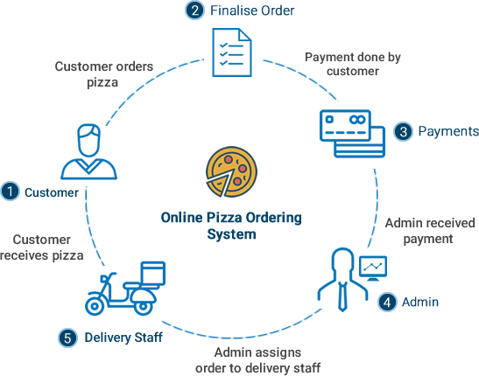

* 1. **Data Flow Diagram****:-**

**Dataﬂow Diagram (Admin) :-**

The Admin gets notiﬁed with customer new order status in web backend. Our application provides admin, an user-friendly interface to manage the complete pizza ordering system.

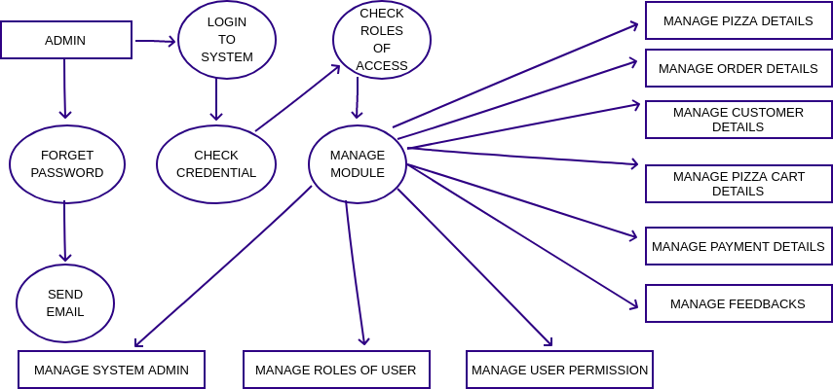

**Dataﬂow Diagram (User) :-**

Online pizza ordering system shows how the system is divided into sub-system, each of which deals with one or more of the data ﬂow to or from an external agent, and which together provides all the functionality of the online pizza ordering system as a whole.

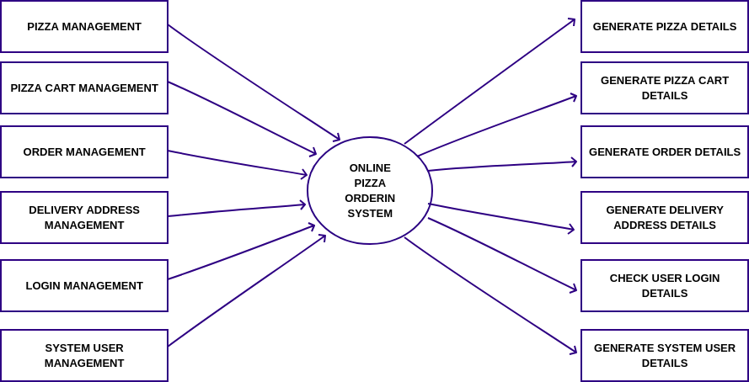

* 1. **Use Case Diagram****:-**

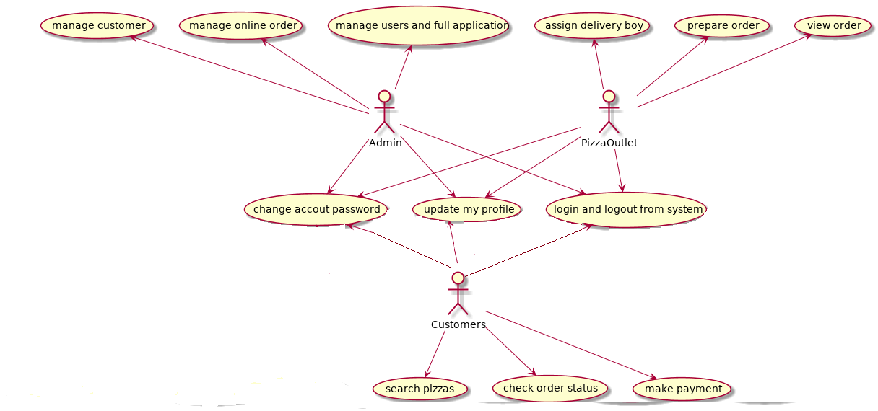

**4.4** **ER Diagram:-**

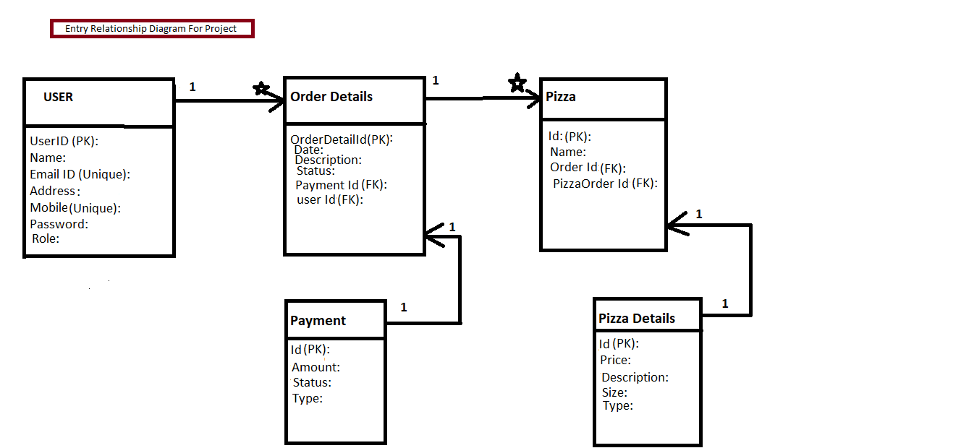

# 5.Table Structure:-

**Table 1: Users**

|  |  |  |  |  |  |
| --- | --- | --- | --- | --- | --- |
| Field | Type | Null | Key | Default | Extra |
| Id | int(11) | NO | PRI | NULL | auto_increment |
| Name | varchar(255) | NO |  | NULL |  |
| email | varchar(255) | NO |  | NULL | email |
| address | varchar(255) | NO |  | NULL |  |
| mobile | int(11) | NO |  | NULL |  |
| password | varchar(255) | NO |  | NULL |  |
| Role | varchar(255) | NO |  | NULL |  |

**Table 2: order Details**

|  |  |  |  |  |  |
| --- | --- | --- | --- | --- | --- |
| Field | Type | Null | Key | Default | Extra |
| Id | int(11) | NO | PRI | NULL | auto_increment |
| Date | date | YES |  | NULL |  |
| description | varchar(50) | NO |  | NULL |  |
| status | varchar(50) | YES |  | NULL |  |
| paymentid | int(11) | YES | MUL | NULL |  |
| userid | int(11) | YES | MUL | NULL |  |

**Table 3 : pizza**

|  |  |  |  |  |  |
| --- | --- | --- | --- | --- | --- |
| Field | Type | Null | Key | Default | Extra |
| Id | Int(11) | NO | PRI | NULL | auto_increment |
| Name | varchar(255) | NO |  | NULL |  |
| orderid | Int(11) | NO | MUL | NULL |  |
| pizzaDetailid | Int(11) | YES | MUL | NULL |  |

# Table 4: payment

|  |  |  |  |  |  |
| --- | --- | --- | --- | --- | --- |
| Field | Type | Null | Key | Default | Extra |
| Id | int(11) | NO | PRI | NULL | auto_increment |
| amount | double | NO |  | NULL |  |
| status | boolean | NO |  | FALSE |  |
| Type | varchar(255) | NO |  | NULL |  |

**Table 5: pizzaDetail**

|  |  |  |  |  |  |
| --- | --- | --- | --- | --- | --- |
| Field | Type | Null | Key | Default | Extra |
| Id | int(11) | NO | PRI | NULL | auto_increment |
| Price | double | YES |  | NULL |  |
| description | varchar(255) | YES |  | NULL |  |
| Size | varchar(11) | YES |  | NULL |  |
| Type | varchar(50) | YES |  | NULL |  |

**Home Page :**

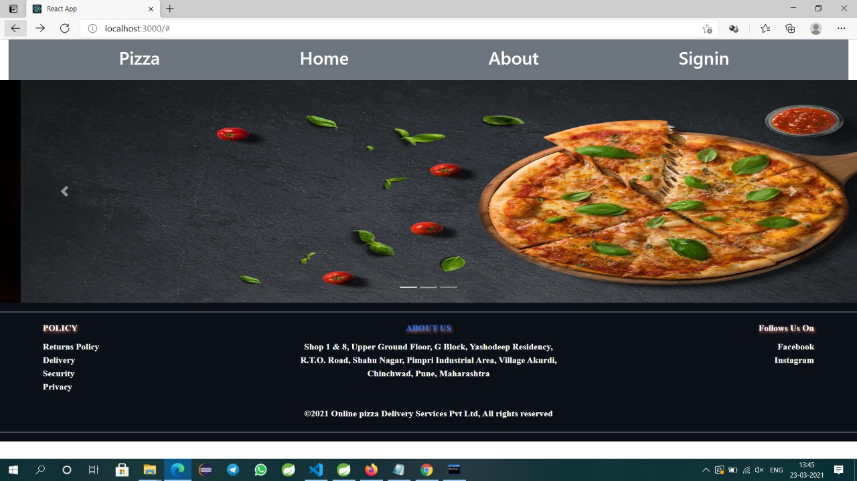

**Login Page :**

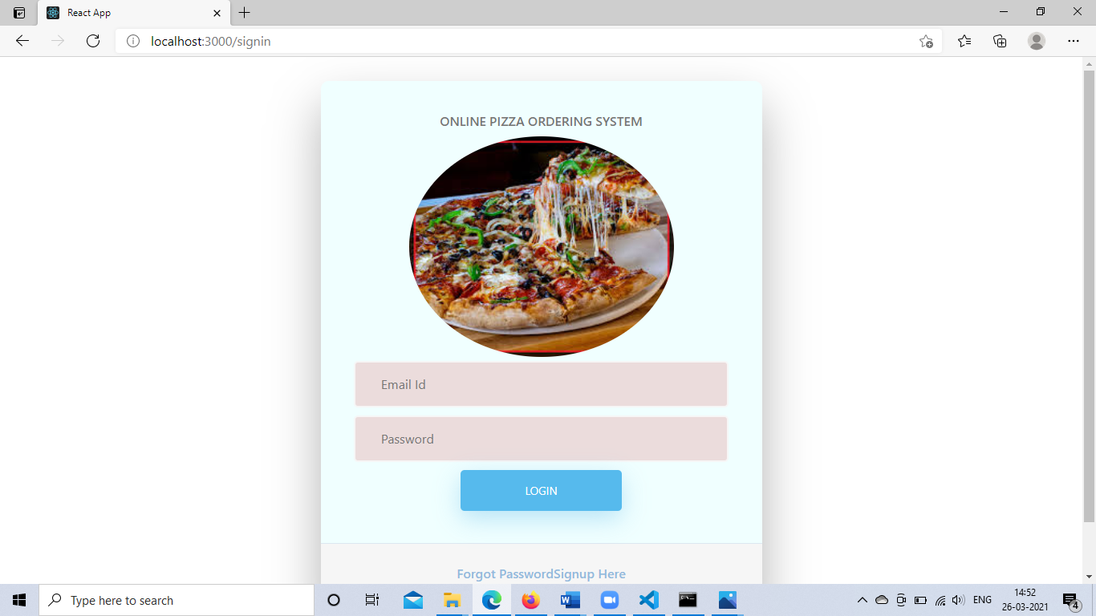

**Register Page :**

# 

**Customer Dashboard :-**

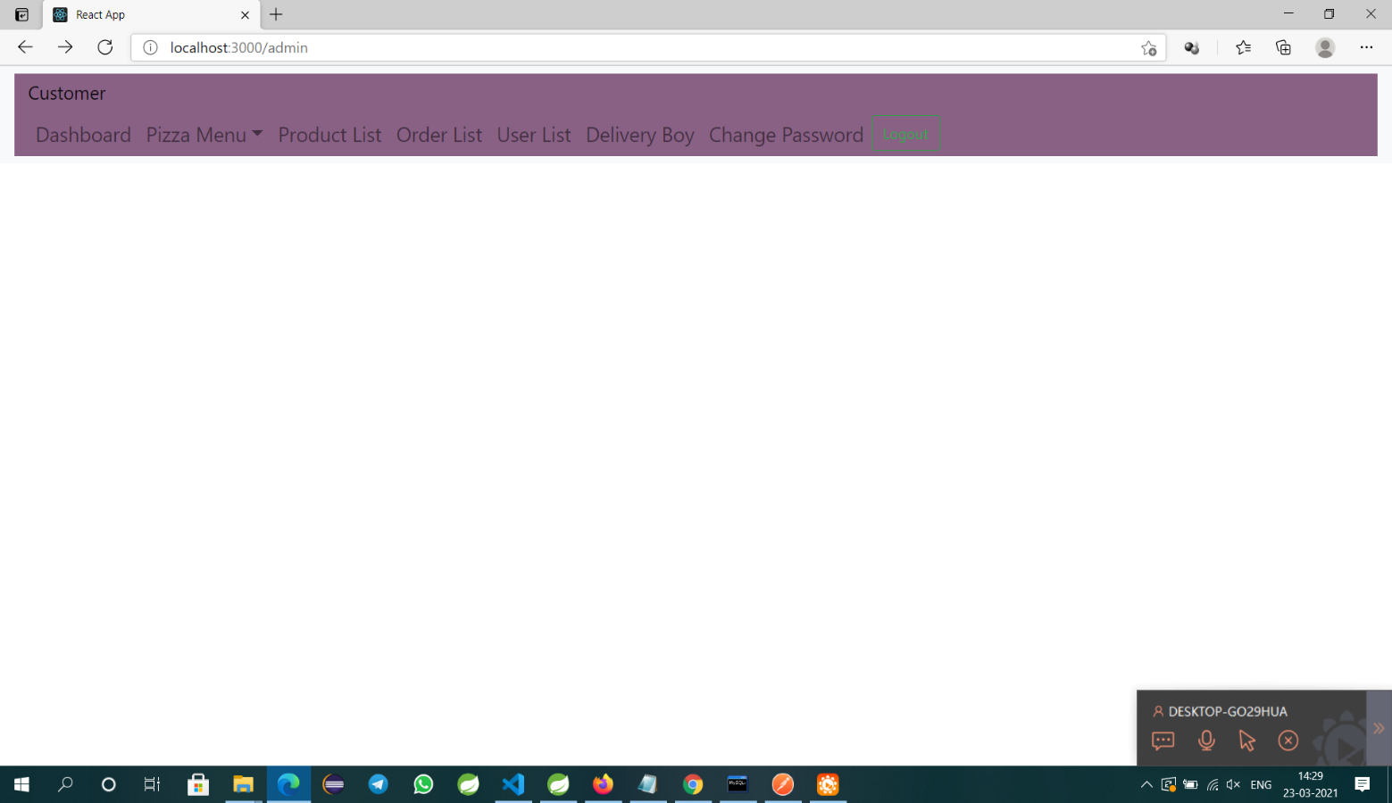

**About page Page :**

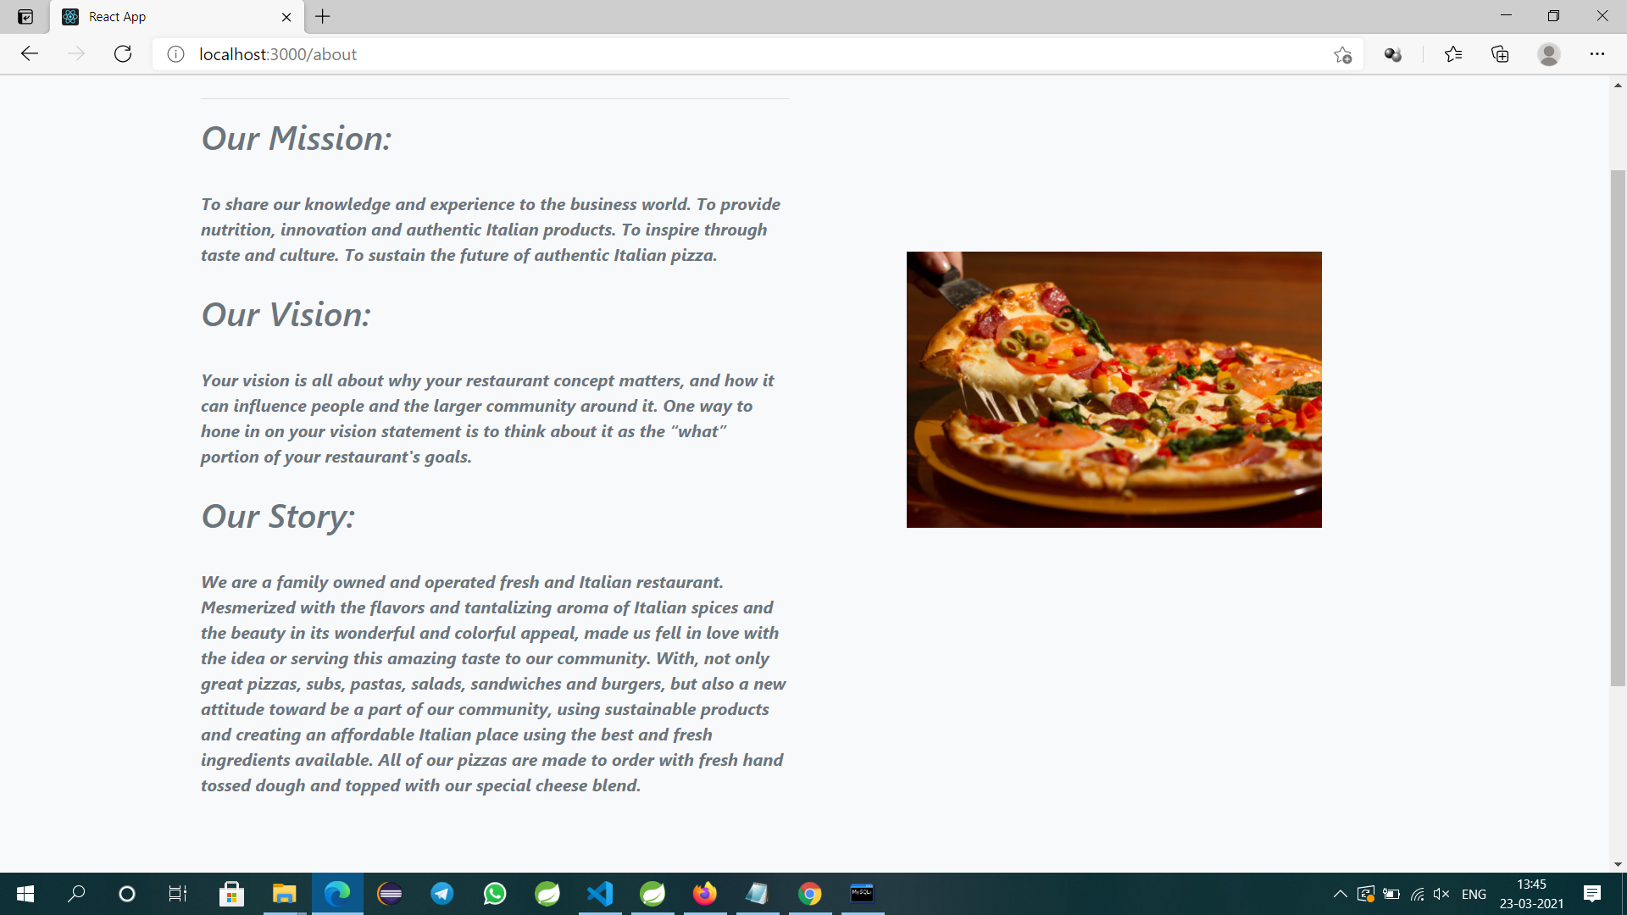

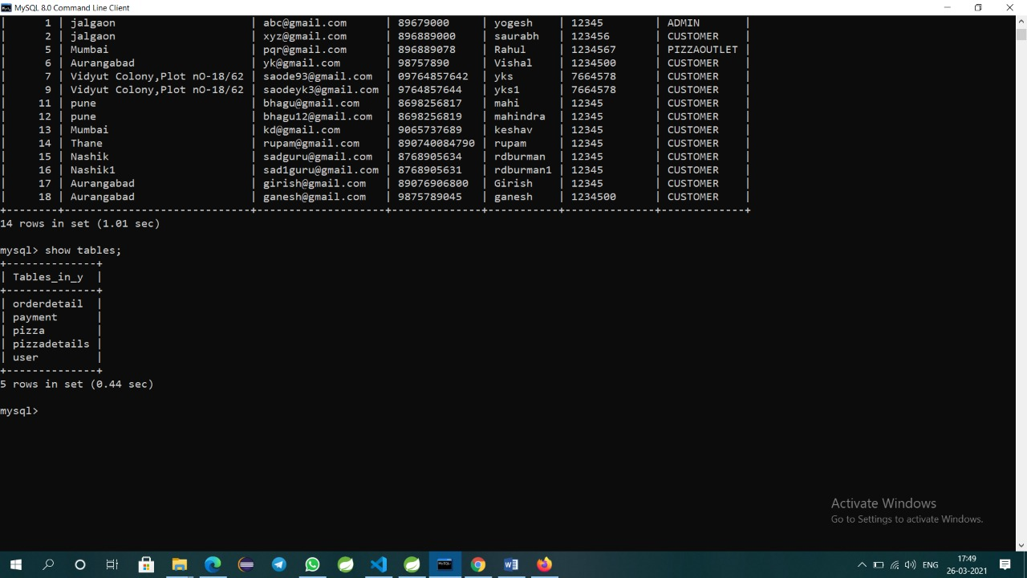

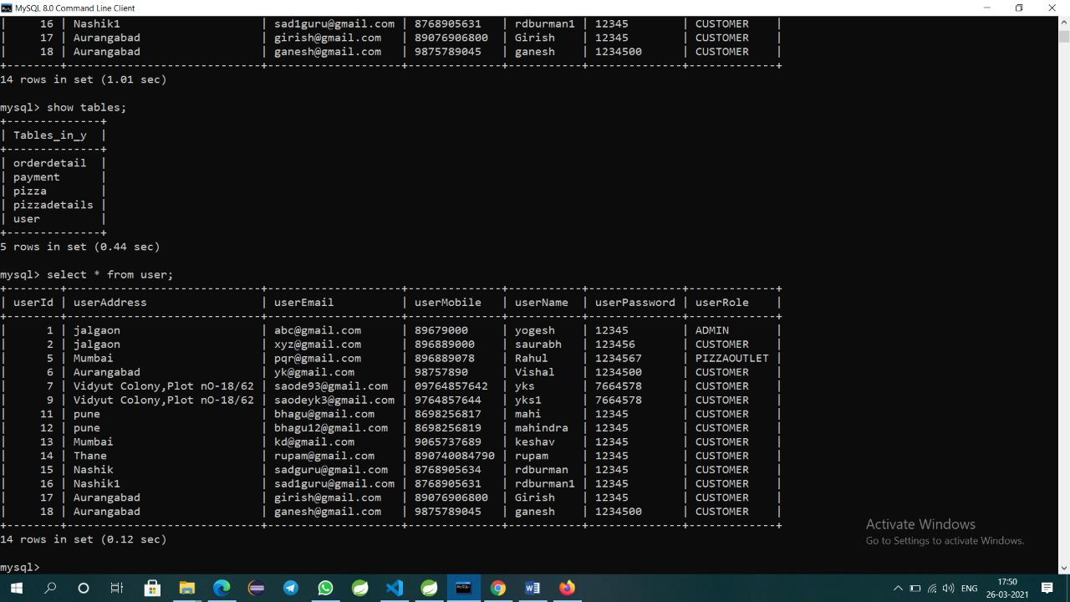

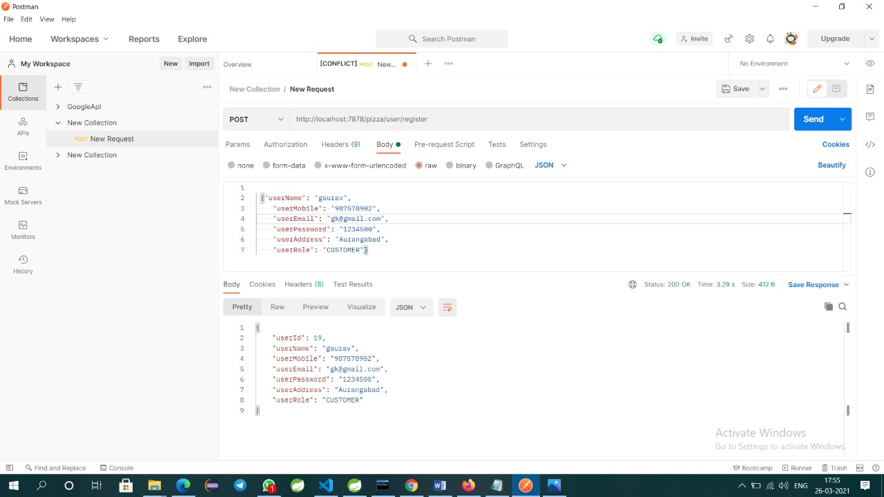

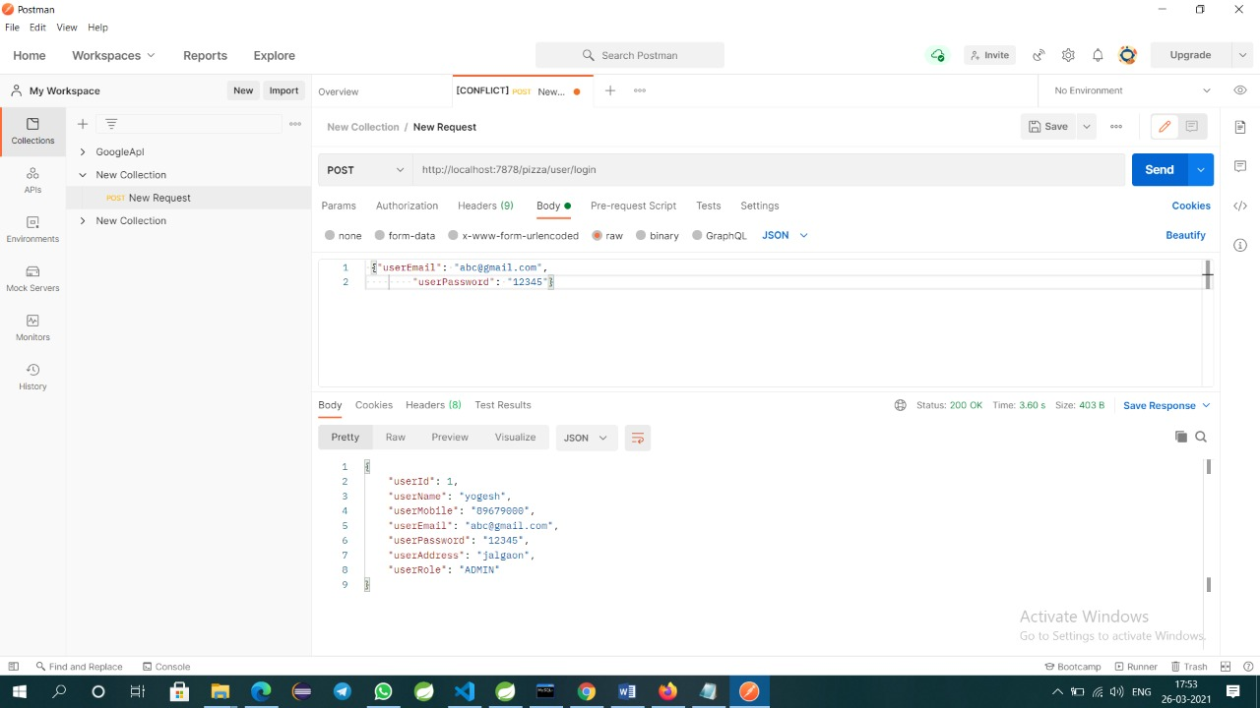



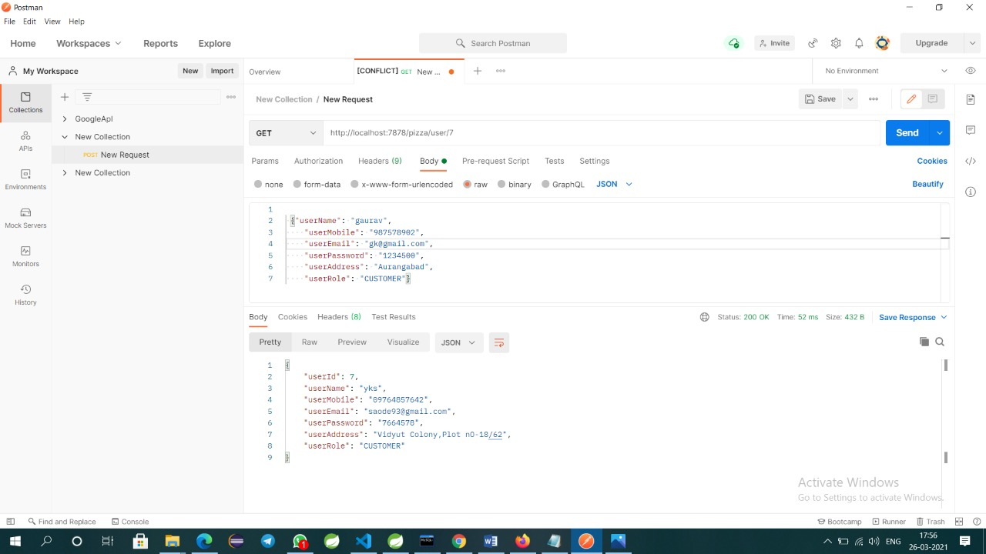

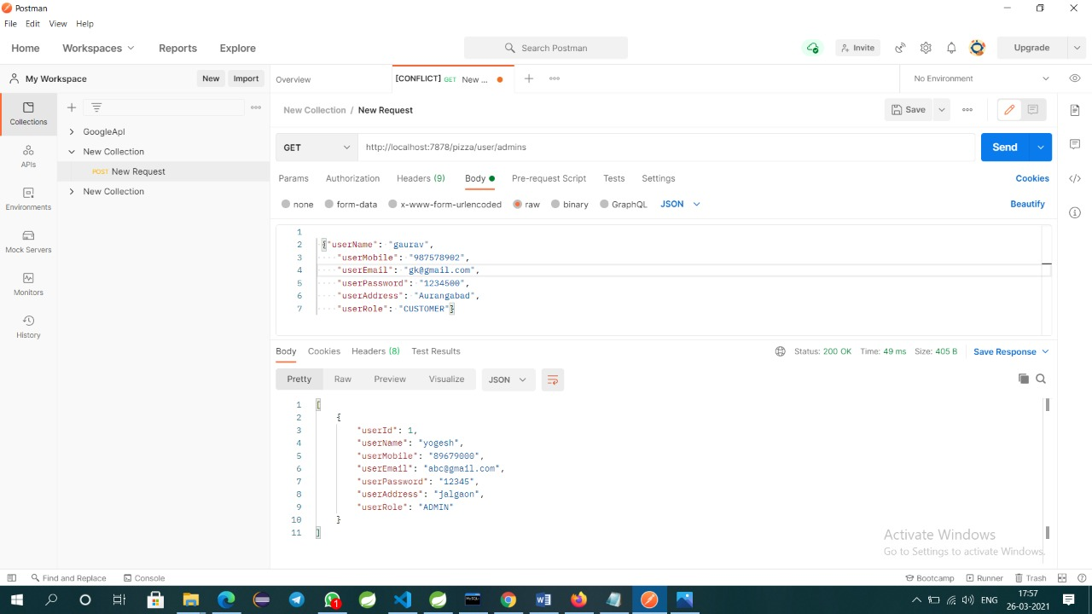

**6.Conclusion:-**

**Future Scope:-**

After reviewing our work, the conclusion is that after many adjustments the system works. As good as it is now, there can still be made many adjustments/improvements. However in the time was given that two persons can work on this project, the overall results are satisfactory in our opinion. The report covers the entire course of the project and results are there were needed. This conclusion chapter is more a description of the process rather than a summary to give all results and facts.

The ﬁrst few days the work progressed slower than expected, in the last days the pace was increased to ﬁnish on time. At several moments, the progress and pace was commented on that "the progress was not good". The results of this report should be suﬃcient evidence that work was done properly.

The conclusion as it is now hopefully gives a understanding in the steps taken to make the report

**7.References:-**

https://[www.dominos.co.in/](http://www.dominos.co.in/) https://[www.pizzahut.co.in/](http://www.pizzahut.co.in/) <http://w3schools.com/>

https://getbootstrap.com/docs/5.0/getting-started/introduction/